You are invited to:

An Alcohol Healthwatch Community Action Workshop:

Auckland’s draft Local Alcohol Policy – Making it work for communities

Tuesday 20th May 2014
9:30am – 2:30pm
(Tea and coffee available from 9:00am, morning tea and lunch will be provided)
Waipuna Conference Suites Highbrook
60 Highbrook Drive, Highbrook, Auckland

Auckland Council have been developing the draft Local Alcohol Policy over the past year. This will affect how available and accessible alcohol is in our communities. Council officers are reporting back to the Regional Strategy and Policy Committee on the 13th May 2014 to seek their approval of the draft policy. Pending any further recommendations from the Committee, the draft Local Alcohol Policy will go out for public consultation between mid June and mid July 2014.
This workshop is aimed to support those involved or interested in community action to reduce alcohol-related harm.
This workshop will include:
- A summary of the evidence on key elements of the Local Alcohol Policy – including trading hours, outlet numbers and location, and one-way doors.
- What’s included in the draft Local Alcohol Policy by Auckland Council
- Findings from a new community survey by Auckland Regional Public Health Service.
- Opportunities to discuss how Auckland’s draft Local Alcohol Policy stacks up against the evidence for reducing alcohol-related harm, and to develop content for your submission.
- Identification of further opportunities to support community engagement in the consultation process.
A template submission will be generated from the workshop to support you and others in writing a submission. Other resources will also be available to take away and use in your communities.
For organisational and catering purposes please RSVP to Alcohol Healthwatch using the registration form attached by Wednesday 14th May 2014.
RSVP and enquiries to Amy Robinson Ph: (09) 520 7038 or Email: amy@ahw.org.nz.
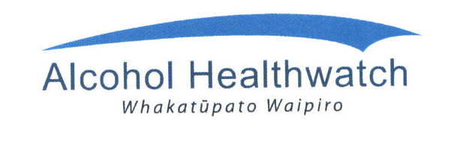

Tuesday 20th May, 2014
9:30am – 2:30pm
(tea and coffee available from 9:30am, morning tea and lunch provided)

Waipuna Conference Suites Highbrook
60 Highbrook Dr, Highbrook, Auckland

Please complete a separate form for each person registering.

Name:
Organisation:
Title/Occupation:
Postal Address:
Telephone:
Email:

Morning tea and lunch will be provided.
Please include me in the catering numbers: Morning tea Yes □ No □
Lunch Yes □ No □

Please let us know if you have any dietary requirements:__________________________________________
Please RSVP to Amy Robinson, Alcohol Healthwatch email: amy@ahw.org.nz
Ph (09) 520 7038 or Fax: 520 7175
By noon Wednesday 14th May, 2014

Please note: Alcohol Healthwatch reserves the right to limit registrations to those with a genuine community health and safety interest and to manage venue capacity.

