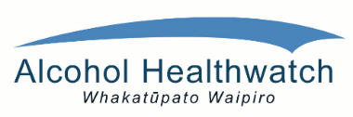

**REGISTRATION:**

**Please confirm your registration by sending the name, organisation and contact details of the person(s) attending before Thursday 23rd March 2017 to:** [**suzanne@ahw.org.nz**](mailto:suzanne@ahw.org.nz) **or ph Suzanne at Alcohol Healthwatch on 09 5207036.**

**Thanks to an HPA grant, we are able to offer this workshop free of charge to those whose registration has been confirmed by email. A light lunch will be included. Please indicate any dietary requirements.**

**WHEN: 9.30am to 4.00pm**

**Thursday 30th March 2017**

**WHERE: Jet Park Hotel and Conference Centre, 63 Westney Road, Mangere.**

*‘This workshop brings to the fore intervention practice shown to maximise success for children and adolescents affected by FASD and for those entrusted with their care.*

*The information shared by our specialist guest speaker will inspire and inform anyone working with or raising Tamariki/Mokopuna where FASD may be a factor.’*

**Alcohol Healthwatch invites you to attend this Fetal Alcohol Spectrum Disorder professional development workshop with Dr Valerie McGinn Neuropsychologist and Director of the FASD Centre Aotearoa.**

# **FASD-informed practice:**

# **A professional development workshop**

# **PANUI**