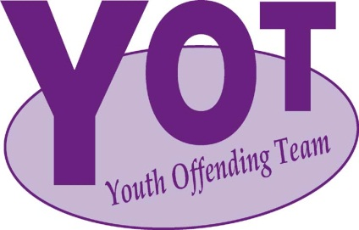
WAITAKERE

PRESENTS
FETAL ALCOHOL SPECTRUM DISORDER (FASD)SYMPOSIUM
KEYNOTE SPEAKERS:
DR VALERIE McGINN
(NZ’S EXPERT ON FASD)
&
CHRISTINE ROGAN
(HEALTH PROMOTION ADVISOR & FASD PROJECT COORDINATOR
- ALCOHOL HEALTHWATCH)
DATE:
FRIDAY 14 NOVEMBER 2014
(PICK ONE OF THE 2 SESSIONS BELOW)
9AM – 12PM 1PM – 4PM
VENUE:
ZEAL @ 20 ALDERMAN DR, HENDERSON

THE SYMPOSIUM WILL BE OF INTEREST TO THOSE
WORKING WITH YOUNG PEOPLE WHO ARE OFFENDING OR AT RISK OF OFFENDING.

THERE IS NO CHARGE.
RSVP ESSENTIAL
CONTACT: MADALENE VIA EMAIL ON
Madalene.viliamu001@cyf.govt.nz
Please provide the following information:
- Name
- Agency
- No.# of Professionals Attending

