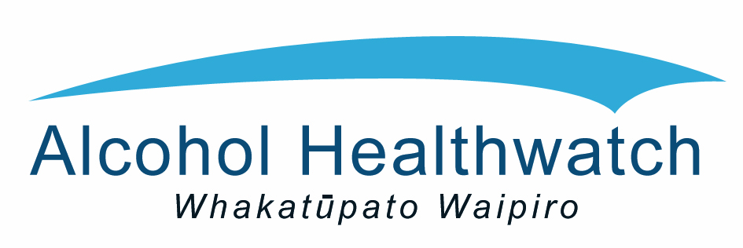

One year on

The Sale and Supply of Alcohol Act 2012
These regional forums will discuss
- what is working well with the Act
- key challenges
- recommendations for the next phase of implementation.
The keynote speaker will be Judith Moorhead from the Alcohol Regulatory Licensing Authority (ARLA). We will also hear from local licensing and enforcement, health, and District Licensing Committee (DLC) representatives.
The outcomes from the three forums will be collated and presented to senior managers of the agencies responsible for administering the Act.
Please register at https://HPA.formstack.com/forms/ssaaforum
There is no registration cost but we would appreciate an email to let us know if you can no longer attend. Priority to attend will be given to those working in the fields of alcohol licensing, alcohol policy, public health, police and DLCs.
If you can no longer attend or for other registration queries please contact Lorraine at registrations@hpa.org.nz or for further information about the forums please contact Amy at amy@ahw.org.nz
All events will run from 9.30am to 4.15pm. Registrations open and tea/coffee will be available from 9am. All three venues have parking available onsite.
Auckland - 11 March 2015 Quality Hotel Parnell, 10-20 Gladstone Road, Parnell, Auckland.
Christchurch - 24 March 2015 The Atrium, 455 Hagley Avenue, Christchurch.
Wellington - 26 March 2015 Te Papa, 55 Cable St, Wellington.

